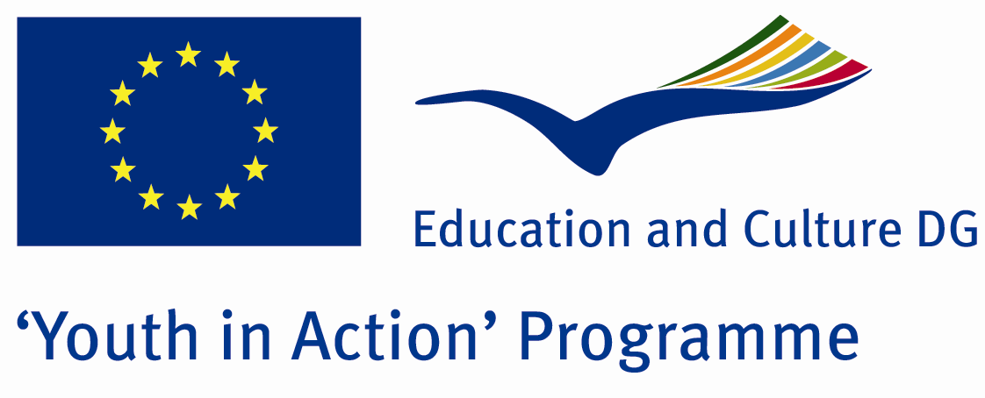

Hot Earth

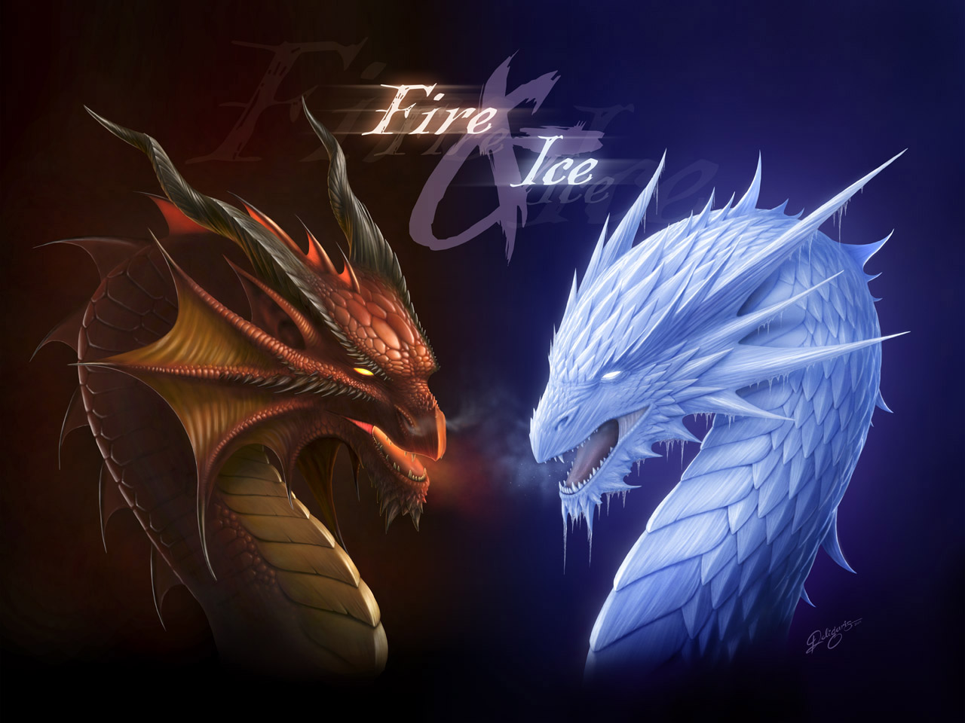

ACTION 4.3 – TRAINING AND NETWORKING

16-23th July, 2012

Balıkesir, TURKEY

ACTION 4.3 – TRAINING AND NETWORKING
16-23th July, 2012
Balıkesir, TURKEY

Please contact directly to;
dogalyasamgrubu@gmail.com
Project Summary; Global warming! 30 years Ago, nobody thought about this word..With global warming, the ecoclimate is broken and it caused too many problems and that is why the human started to interrogate this word.Thw world is 4567 bilions years old and the population of it is 7.5 bilions..It is getting more.With economical reasons, like industry, sera gas .e.t.c , it became worse.In 21th century, most of the scientists are searching for solution about this subject.And they think that until 2025, half of world will face to face with famine…

In this Project, we will talk about global warming reasons, some solutions and as people what should we do?And moreover, friendship, to have fun and cultural Exchange..

If you want to join this Project, please contact with us.

Project Title; Fire And Ice

Date and Venue ; 16-23th July, 2012 Balıkesir, Turkey .

Target Group ; Municipalities, City Councils and Non-Governmental organizations,
youth groups,culture and art groups,e.t.c

Participants ; 5 people from each country (over 18 -25 ). Totally 8 countries.

Conditions ; Accommodation, board and programme costs will be financed through European Commission Youth in Action Programme (Action 4.3). Travel costs will be reimbursed in 70% (APEX Tarrifs). Organizations from all 27 EU member countries plus Liechtenstein , Norway and Iceland are eligible to take part.

Working language: English

Organizer;Doğal yaşam Grubu
How to apply: If you are interested, please send your Part III forms to
by e-mail please (in word file). Scan Part3 format is enough for application.(Fulfilled Part III which you can find in the attachment, of course signed and stamped) ..

If you have any questions you may contact with:
dogalyasamgrubu@gmail.com
Deadline: 10th October 2011

